DISCUSSION POINTS

Need info on the variance of body size among non-Hawaiian species of Drosophila. The variance among species needs to be compared to the variance among populations within species and to the variance between treatments (wind tunnel and wild type) in Gen 615 data.

MUST ADDRESS HOULE 2019 PAPER SELECTION WING ALLOMETRY IN THIS

***************************************************************

The 615 analysis is a chance to address the plasticity of shape demonstrated by the original allometry papers. The clear but instated inference of those was that if wing morphology is plastic, yet essentially constant, it must be optimal and maintained dynamically by normalizing selection on optimal phenotype. What would natural selection do under radically different, yet extreme, selection???

The existence of a developmental program that generates shape differences in response to developmental temperature should not strain our credulity, considering that there are many cases where wholly different morphotypes can develop from identical genomes by environmental triggers. Surely it was natural selection for adaptation that fashioned the developmental dichotomy that elicits the migratory morph of locusts when population density reaches a certain density. What may be new in the present case is that these effects of temperature on wing and body size relations are not dichotomous responses with a threshold condition, but a continuous gearing of the wing/body ratio to temperature. But why would a proportionally larger wing be better for a colder fly? It may be because cooler air is more fluid (less viscous) and offers less resistance to the wing.

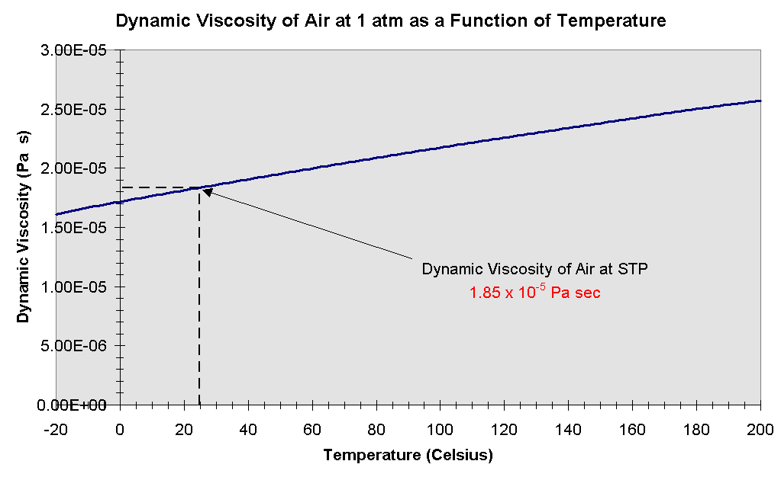
http://www.ce.utexas.edu/prof/kinnas/319lab/Book/CH1/PROPS/dynviscgif.html

